NOISE MONITORING SYSTEM

ABSTRACT:

In infrastructure and industrial plants the rapid growth creating environmental issues like pollution (Air, Water, Noise), climate change, malfunctioning and has greatly consequence for the requirement of an, operationally adaptable, efficient, cheap and smart monitoring systems. In this context where combination of many challenges of computer science, wireless communication and electronics, the smart sensor networks are an emerging field of research. In this paper a solution to monitor the air and noise pollution levels in industrial environment or by using wireless embedded computing system a particular area of interest is proposed. The technology like Internet of Things (IOT) is included in the form of solution which is outcome of merged field of computer science and electronics. For monitoring the fluctuation of parameters like noise and air pollution and also humidity and temperature levels from their normal levels in this case the sensing devices are connected to the embedded computing system.

**INTRODUCTION:**

Nowadays, in Metropolitan cities air and noise pollution have become a serious issue, due to high decibels and toxic gases present in the environment which directly affect human health and thus needs special attention. Therefore, it has now become necessary to control pollution (air and noise), Temperature, and humidity to ensure healthy livelihood and a better future. In this paper, an effective implementation for the Internet of Things is used for monitoring atmospheric conditions of the environment like air pollution and sound pollution and also we Monitor the Soil moisture monitoring system that helps the government authorities to know the information about dry soil areas in the agricultural lands within a village, town, or maybe a state in order that the required precautionary steps will be taken to create such lands fertile. Currently, Air contains harmful gases, such as CO, Smoke, LPG, which cause harm to the environment and human health such as asthma , detecting these gases using MQ135, MQ7 sensor. Soil contains different moisture levels which may harm crops we need to determine the moisture level that is suitable for agriculture detecting with Soil moisture sensor Various kinds of environmental pollution cause major problems to mankind. Temperature and humidity sensor control the evaporation releases from the industry. Sound sensor detects the high levels of sound plays an important role in Traffic. Air contains harmful gases which harm human health. The above problems motivated us to implement this project.

**METHODOLOGY:**

Proposing the combination of air & sound pollution, temperature,  humidity, soil monitoring and notification systems using IOT. Detection of harmful gases such as CO, CO2 etc. using MQ7 gas sensor. Detection of sound level using LM393 sound sensor. Implementation of temperature and humidity by using DHT11 sensor and detection of soil moisture level by using high sensitivity moisture sensor. Usage of Arduino to get the required parameter values as a message to the mobile phone & when it crosses the threshold there will be notification to the concerned user.

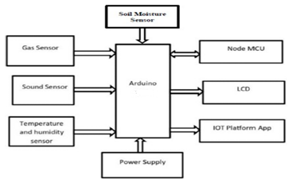

**FLOW DESIGN:**

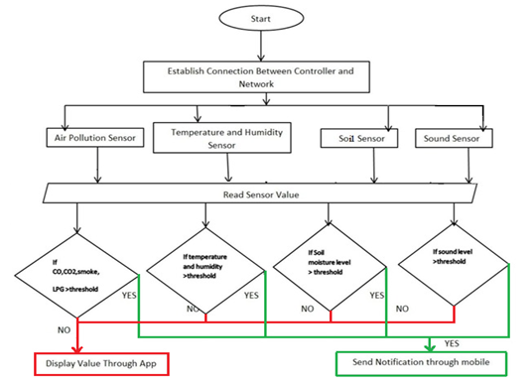

**LITERATURE REVIEW:**

. The IoT system designed measures pollution in real time at any desirable location and hence is cost effective when compared to the existing system of stationary monitoring. It also avoids the problem of inconsistent pollution value. The user interface helps the people to know the pollution level at a certain area and the health hazard associated with it. People with specific allergies can refrain from visiting the place and hence be free from air prone health hazards. The system is scalable and supports any number of IoT devices that may be deployed since it’s based on cloud platform. The interface supports all operating systems too. It is found that traffic pollution in Coimbatore city is relatively low. Due to the large number of foundries, brick kilns and textile mills the industrial pollution is found to be more. There is also considerable level of pollution in residential zones where textile mills were present. This system may be enhanced to measure more air pollutants. The data acquired may be used to predict pollution in similar zones depending on the location and vicinity of the type of industry in that location. This is expected to reduce the cost of pollution monitoring as well as it helps the people to choose their residential area depending on the associated health hazard.

The device provides a big humanitarian needs near schools near playgrounds in monitoring the quality of air the children breath, in factories or high traffic area where the emission is higher and affect many people, in developing countries and in places where the air quality is very poor and can be a health hazard by alerting the people to threatening levels of these realized pollutants. Also, this prototype can be continued as low cost mobile device that anyone can use and it monitors the air along once path.

**CONCLUSION:**

The system to observe various parameters of environment using Arduino microcontroller, WSN and GSM Technology is proposed to enhance quality of air. With the utilization of technologies like WSN and GSM enhances the method of monitoring various aspects of environment like air quality monitoring issue proposed during this paper. so that the required action could also be taken. It is estimated that this technique will have an excellent acceptance within the market because it may be a centralized system for an entire monitoring function. The smart thanks to monitor the environment and an efficient, low cost embedded system is presented with different models during this paper. In the proposed architecture function of various modules were discussed. The noise and air pollution monitoring system with Internet of Things concept experimentally tested for monitoring two parameters. This model are often further expanded to watch the developing cities and industrial zones for pollution monitoring. To guard the general public health from pollution, this model provides an efficient and low cost solution for continuous monitoring of environment and soil moisture monitoring. The flexibility of the sensor node and transceiver node to integrate to other sort of sensor was tested and implemented on this work. The characteristic curve proved the accuracy of the sensor in determining the soil moisture content. Monitoring of Turbidity, PH & Temperature of Water makes use of water detection sensor with unique advantage and existing GSM network.